* **Lab Task 2:**

The HR department needs a report of all employees. Write a SQL statement to display the last name, department number, and department name for all the employees.

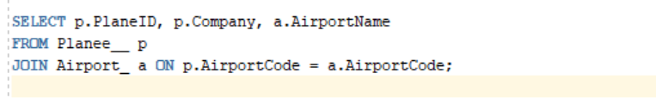

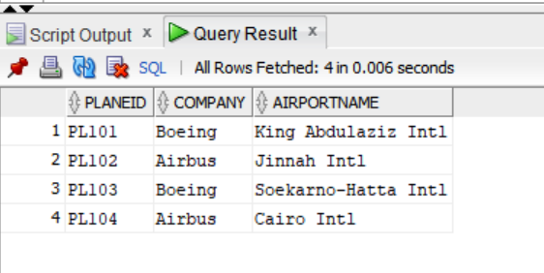OUTPUT: